Mathis Doulson

31/05/2021

Paris

# The Battle Of Neighborhoods

## Indian Restaurant in Paris

Before you start reading, I will encourage you to download this project notebook from my [GitHub repository](https://github.com/Amged-Elsheikh/Coursera_Capstone/blob/main/NYC_Airbnb.ipynb). Lastly, please note that the aim of this article is to get IBM Data Science Professional Certificate.

# Introduction

## Background

Paris is one of the biggest cities in the world with an area equal to 105 km² which contains 80 different quarters in 20 Arrondissements and a population of 2.175 million. Most office workers and tourists might not have time in the morning to make their own breakfast, instead, they have it in cafés. In this regard, opening up such a business in Paris is an attractive idea. My client and friend of mine is willing to open one of these good old French cafés in Paris and he wants to know where the best place would be. So, we want to know where to open a new café/coffee shop to target more customers using Foursquare API location data and quarters (*quartiers*) venues details.

## Targeted audience

Investors who are interested in opening a new café/coffee shop in Paris.

## Problem

I will explore the quarters in Paris and answer the question: "Where is the appropriate place to open an café in Paris ?". The business owner wants to ensure a steady and sustainable business. We therefore need to meet the following requirements:

* The store needs to be strategically located inside a very dense area, demographically speaking
* Confirm any assumption by means of modeling and testing the data. Specifically, visually cluster common restaurants in Paris by neighborhood.
  + Locating the new restaurant according to these requirements will ensure the following:
    - lowest cost for delivery
    - shortest travel time to his store for his clients
    - overall lower run costs
    - overall greater customer satisfaction
* Additionally, determine that a good number of people can frequent this type of eating place with sustainable frequency inside these neighborhoods.

# Data

## Data Sources

Two different kind of data is needed for the comparison.

* **City quarters and their respective geographical data:** in order to analyze the cities on a meaningful level, they need to be divided into different areas, in our case in *quartiers (*subdivisions of the 20*Arrondissements* delimiting Paris). I was able to find the list of the 80 *quartiers* of Paris on Wikipedia[1]. I thus web-scrapped the HTML page in order to convert this list into a data frame usable with pandas.

Using the *Geocoder* python library, I was able to get the geographical coordinates for each quarter.

* **Venue data:** This data, including the Venue name, its category, latitude and longitude, is gathered using the Foursquare API[2].

1. Data Cleaning
2. Obtaining the list of quarters, density and geographical coordinates.

After scraping the table of different *quartiers* of Paris from Wikipedia as well as their according density, I had to get rid of useless columns. I then renamed the different columns and cleaned the display of *arrondissements* as for having only the numbers of the *arrondissement*. From there, I was able to get for each quarter the precise geographical coordinates via the **Geocoder API**. See below a sample the final pandas data frame :

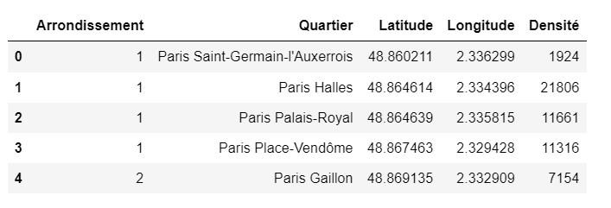

1. Obtaining for each quarter, the most famous venues

A rich collection of features was selected from the Foursquare API as follows :

* Venue Name
* Venue Latitude
* Venue Longitude
* Venue Category

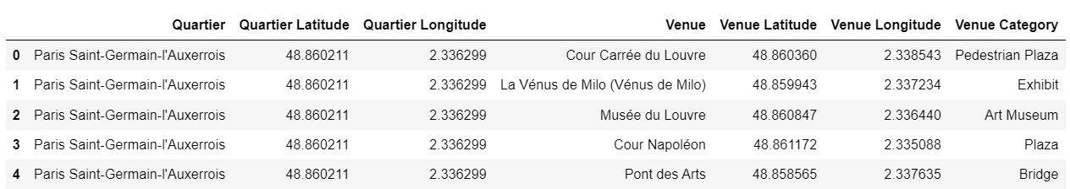

Pre-processing the data :

The 253 unique venue categories were converted into categorical (binary) variables, using one-hot-encoding in order to perform the K-means algorithm. Once each category was transformed into dummy variables, I was able to group rows by neighborhood and compute the mean of the frequency of occurrence of each category :

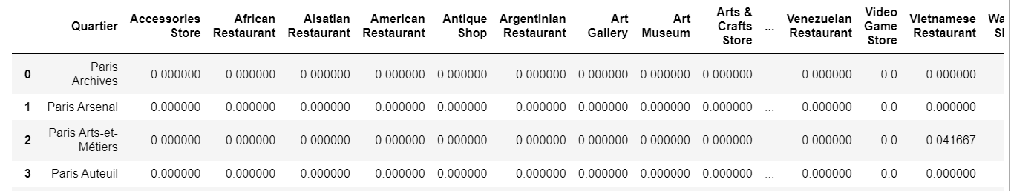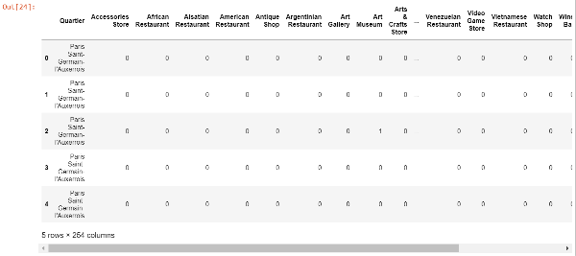

# Methodology

## Exploratory Data Analysis

1. Geolocation of each quarter

Once I obtained geographical coordinates for each quarter, I was able to display each of them of a map, to make sure all the coordinates were actually situated in Paris. I used Folium from Leaflet API, an open-source JavaScript library for interactive maps.

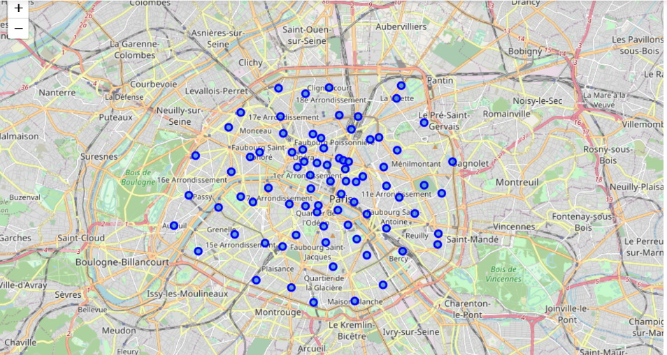

1. Venues Categories

Now that I had associated quarters with all the relevant venues, I was able to determine the number of distinct venues categories. I observed 253 venues categories that have been raised on the Foursquare API for the whole city of Paris. I plotted the 20 most frequent venues categories with their frequency of appearance in Paris :

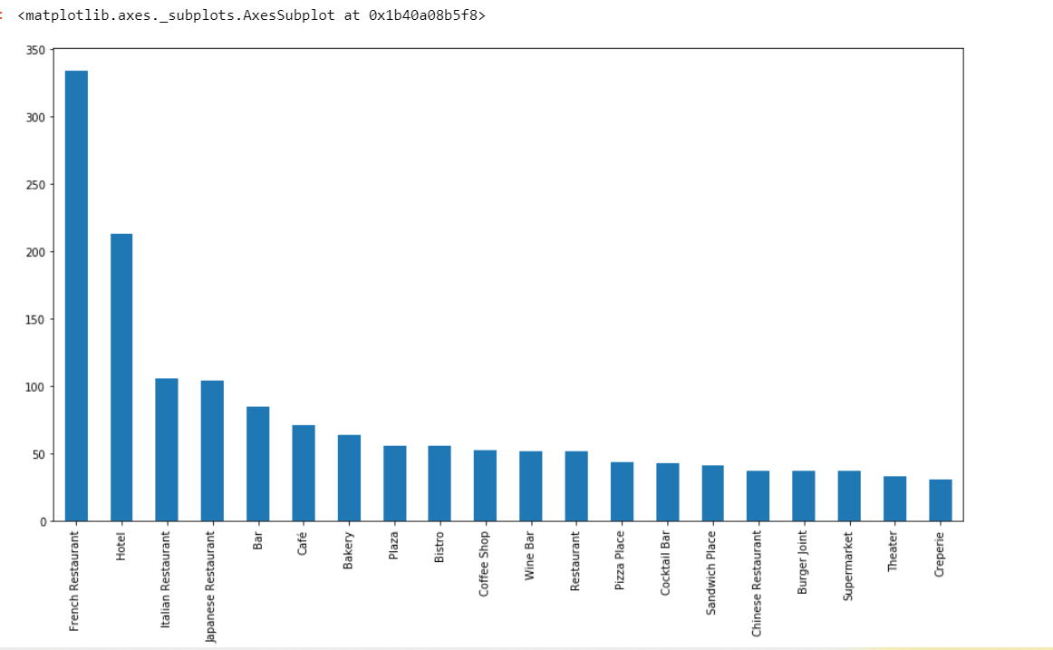

In first place, it can be observed that restoration industry is very prominent in term of frequentation in the city of Paris. Cafés occupy the 6th rank among most frequented venues categories.

1. Frequency of venues per quarter

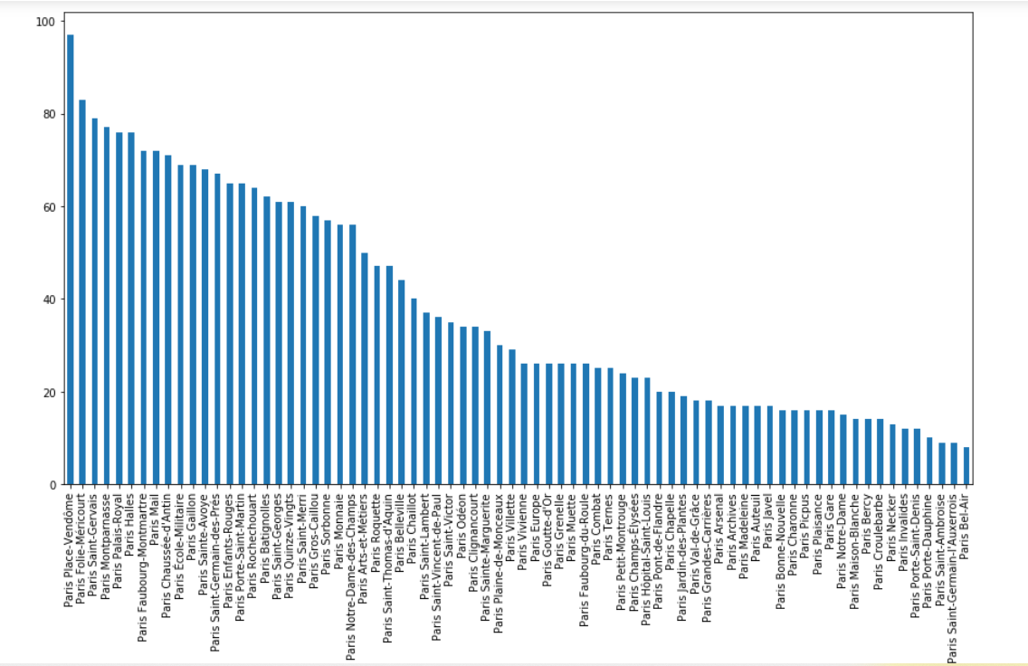

As it can be seen above, the number of different venues per quarter is unequally reported on the foursquare API. That’s why we had to normalize the data, and to compute the mean of frequency (cf. *pre-processing* page 3).

# Clustering

For this project, k-means is an appropriate clustering algorithm. Because we have a unlabelled dataset, so this is an unsupervised learning project. K-means clustering aims to partition n observations into k clusters in which each observation belongs to the cluster with the nearest mean. By clustering the neighborhoods, we can find out the pattern in them, identify the identical neighborhoods and see which is our target. One difficulty of k-means is to determine the hyperparameter k. Based on the inertia loss indicator, I chose k=8 for my optimum number of clusters.

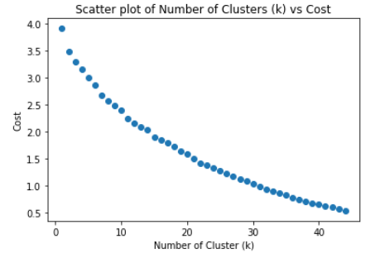

# Results

## Geolocation of the clusters

After running the K-means algorithm on my pre-processed data frame, I was able to display each cluster on the map, as such :

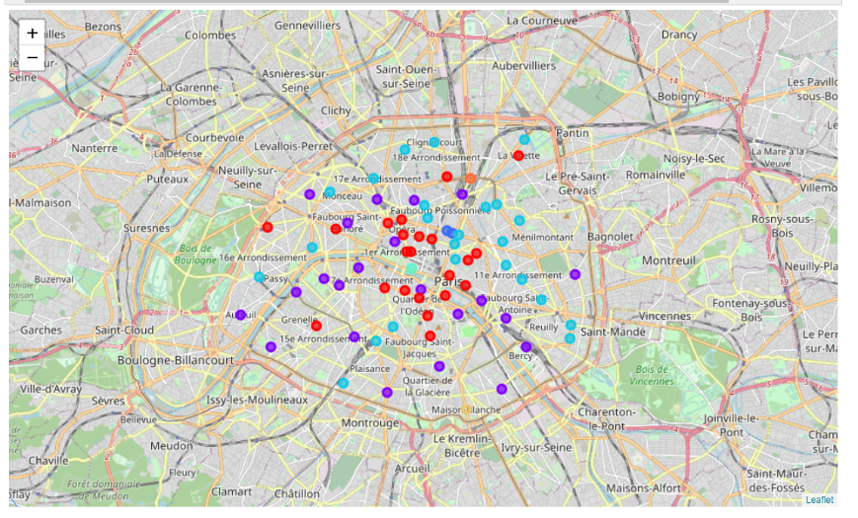

## Examine each cluster

In order to determine which cluster will suit the most for my client, I decided to display for each cluster the 8 most common venues for each quarter of the cluster.

For instance, let’s have a look at the 1st cluster :

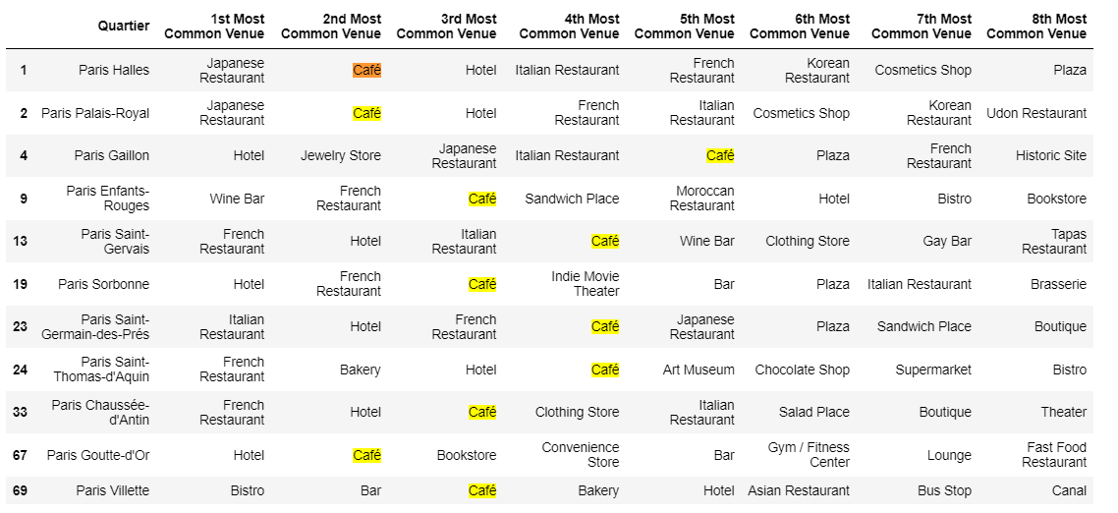

This cluster is mainly composed Hotels, French Restaurants, Cafés and other restauration places.

I decided to make a Wordcloud for each cluster in order to visualize more easily the essence of each cluster. Here is an example for clusters 1, 2 and 3.

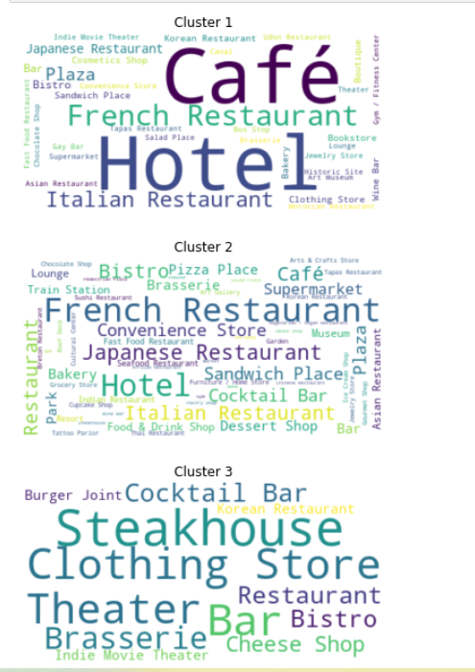

With a closer look at each cluster, it can be observed that Cluster 1 match our requirements, due to the high frequency of cafés that it features. Restricting our study to this sole cluster, we are now dealing with 11 quarters.

## Visualizing density for each relevant quarter

Now that we’ve found our cluster, it’s now possible to merge each quarter with their demographical density scrapped on Wikipedia. I displayed the density of each quarter from the relevant cluster on the map below :

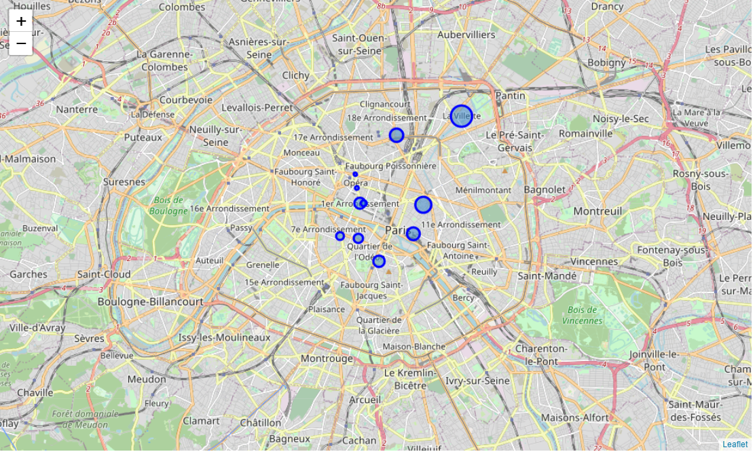

## Answer the question

From this map, we observe that quarters of interest in terms of cafés frequentation are essentially situated in Paris hyper center. In terms of demographic density though, my client may prefer setting up his café in *La Villette* where population density is the highest

# Discussion

The assignment imposed the use of Foursquare in order to determine the most common venues for each cluster in order to cluster the map by common venues. The sole use of Foursquare is questionable. Indeed, Foursquare users may not be very representative of the whole frequentation in Paris. Biases can exist, for instance people using Foursquare are likely to be young people, a sociologically distinctive cohort whose tastes and choices are very different from adults and older people who are unlikely to report their visits on the social media.

As far as the algorithm is concerned, we obtained quite distinctive cluster with a good intra-class variance/inter-class variance ratio.

# Conclusion

In this project, I had to use the location data from Foursquare to solve the problem " Where is the appropriate place to open up a café in Paris ?". I collected the quarters data from the Wikipedia page, and formatted it such as to be able to get the coordinates for each of them through *geocoder* API. Then I was able to invoke Foursquare's API to get the frequented venues for each quarter. After pre-processing the data, I used K-Means algorithm to determine which clusters were the most likely to suit my client. Crossing the relevant clusters with demographical density data, I determined which quarters were the most suitable.

1. https://en.wikipedia.org/wiki/Quarters_of_Paris
2. Foursquare City Guide, commonly known as Foursquare, is a local search-and-discovery [mobile app](https://en.wikipedia.org/wiki/Mobile_app" \o "Mobile app) developed by [Foursquare Labs Inc.](https://en.wikipedia.org/wiki/Foursquare_(company)) The app provides personalized recommendations of places to go near a user's current location based on users' previous browsing history and check-in history.